Ex. No. : 04 Date : 07/08/2026
Register No. : 240701181 Name : Harshavarthini Annamalai
REPORTS
- Aim
To study the use of the Zia Assistant in Zoho Creator for building an application with natural-language assistance, generating application components, and simplifying the development process with minimal manual coding.
- Introduction
Zia is the AI assistant built into Zoho's suite of applications. Within Zoho Creator, it can interpret a plain-language description of a business requirement and translate it into concrete application components — forms, fields, and reports — cutting down on the repetitive configuration a developer would otherwise perform by hand.
ZIA ASSISTANT
Rather than adding forms and fields one at a time through the builder, a user can describe the application they need in ordinary language. Zia interprets the description and proposes a matching set of forms and fields. The developer then reviews what has been generated, corrects or extends it where necessary, and takes it forward to testing and deployment
- Objectives of the Study
• To understand how Zia Assistant supports low-code application development.
• To build an application from a real-world requirement using AI assistance.
• To identify appropriate forms and fields for the chosen application.
• To examine how far Zia can reduce manual, repetitive configuration work.
• To test and refine the AI-generated application before publishing.
- Application Selected : Student Registration System
A Student Registration System is chosen for this experiment. The application is meant to record new-student registrations, the courses they enroll in, and their admission status, so that the registration office can track applicants from submission through to confirmed enrolment.
- Procedure:
• Sign in to Zoho Creator
• Create a New Application with Zia
• Describe the Requirement to Zia
• Review the Generated Forms
• Establish Relationships

• Preview and Test the Application
• Save and Deploy

- Advantages
• Natural-language interaction makes application creation easier to understand.
• Reduces repetitive configuration and manual development work.
• Helps users create application components more quickly.
• Supports rapid prototyping of business applications.
• Generated components can be reviewed and customised by the developer.

- Limitations
• AI-generated components still require user verification and modification.
• Available Zia capabilities depend on the platform and enabled features.
• Complex application requirements may need additional manual configuration or scripting.

Screenshots:

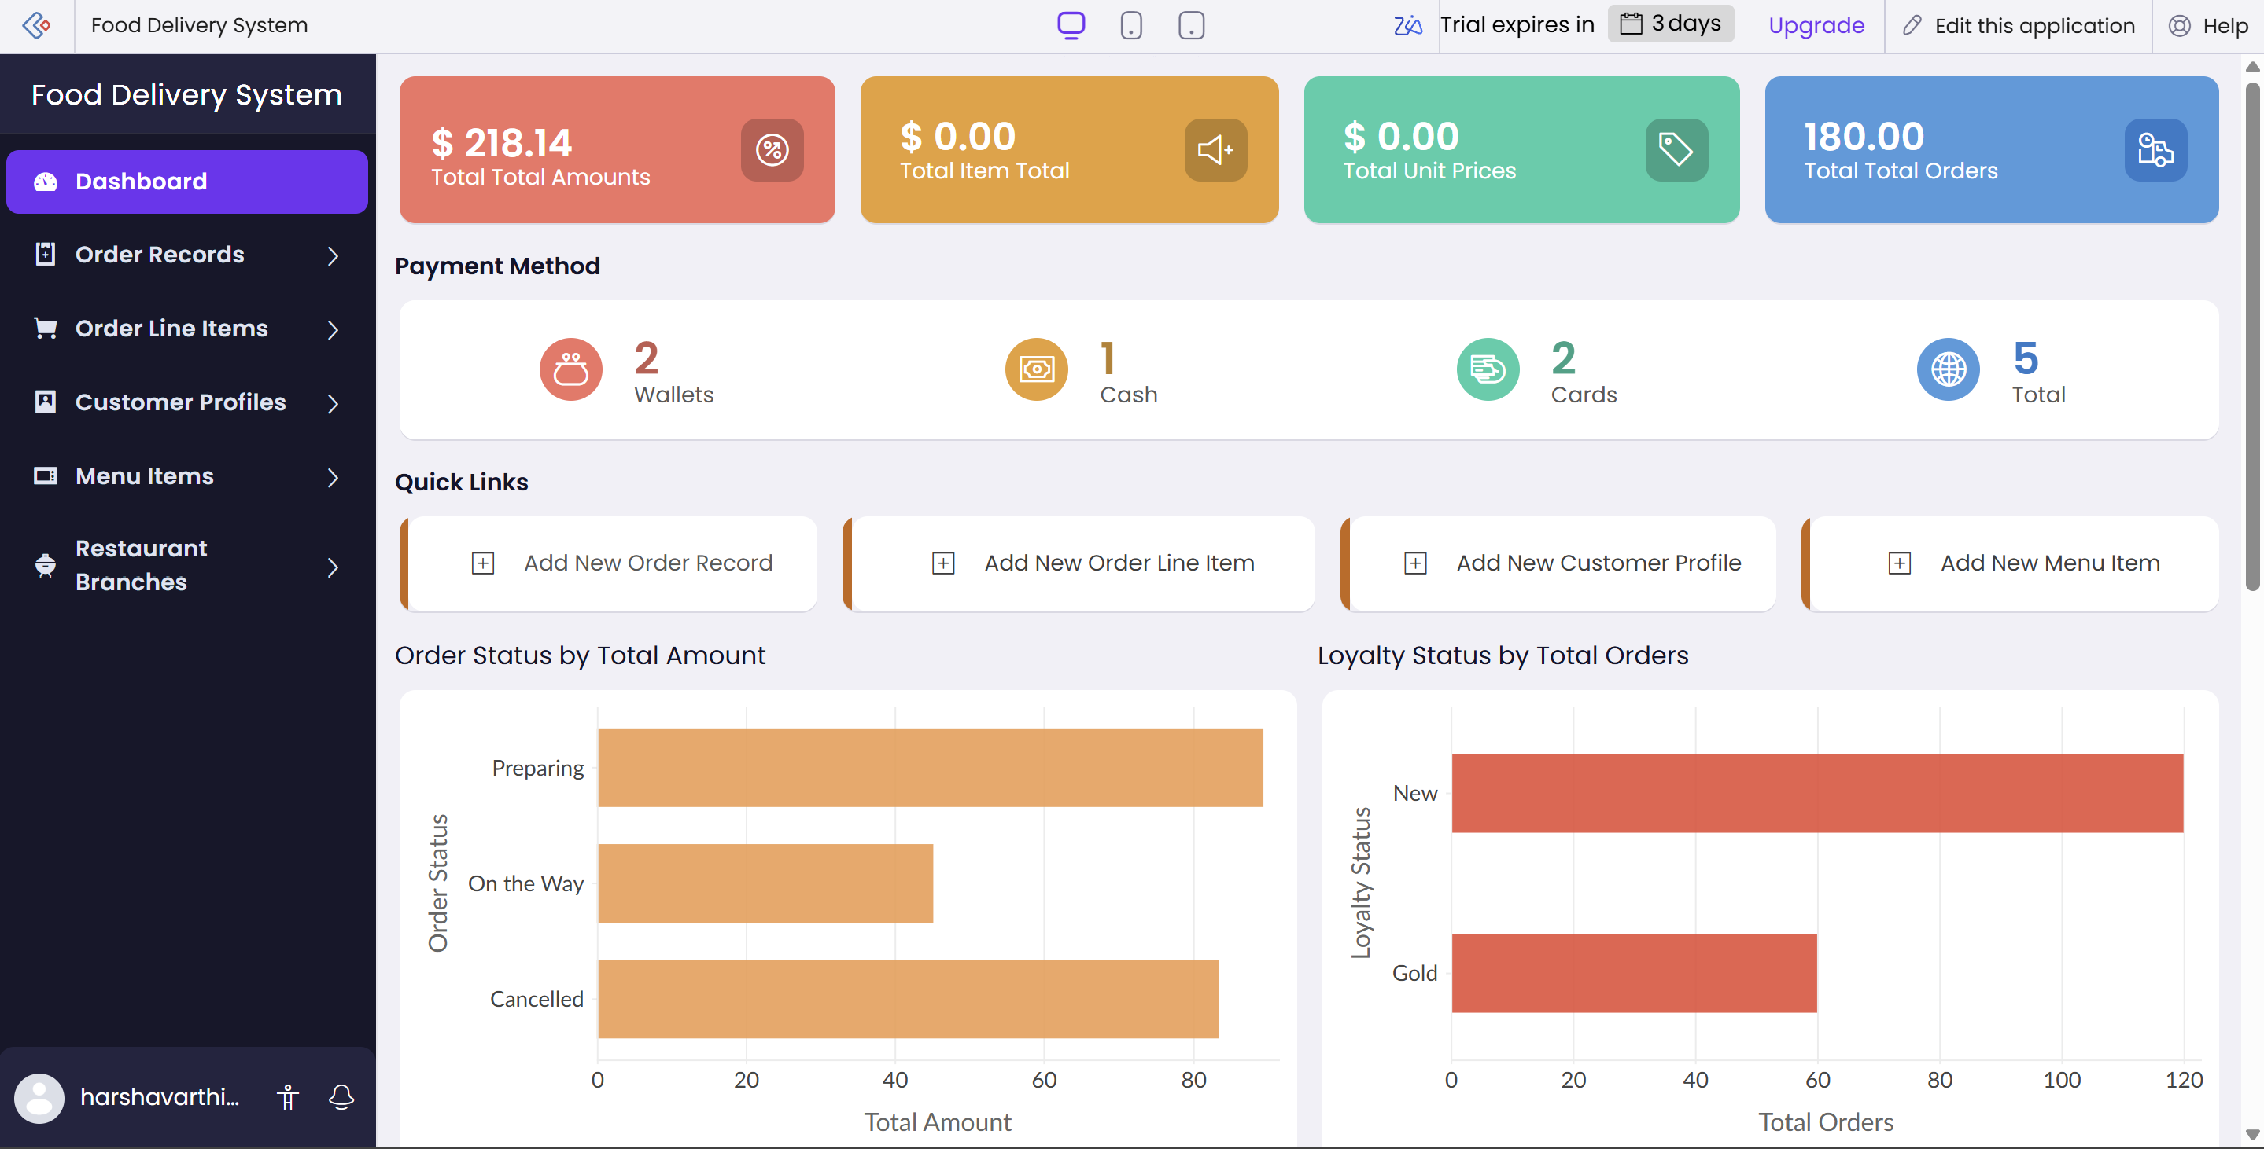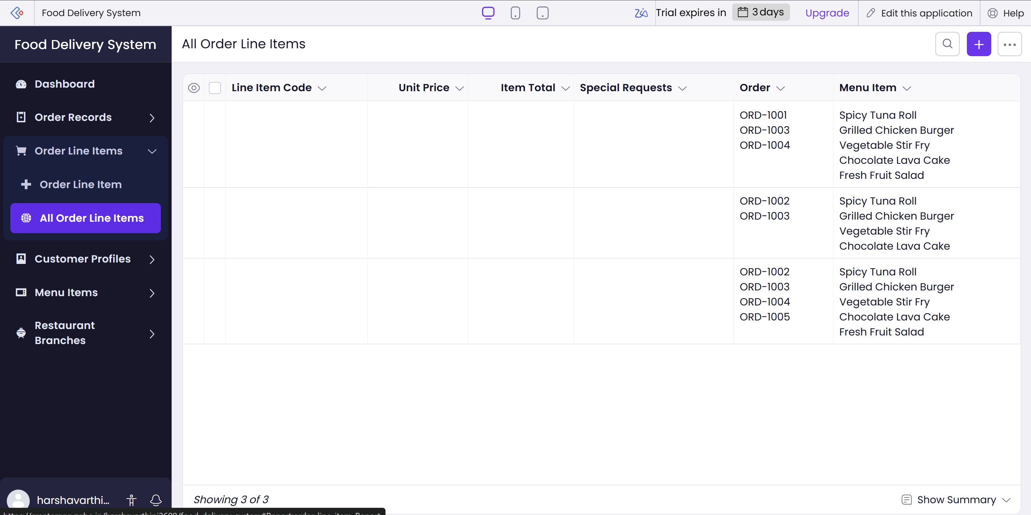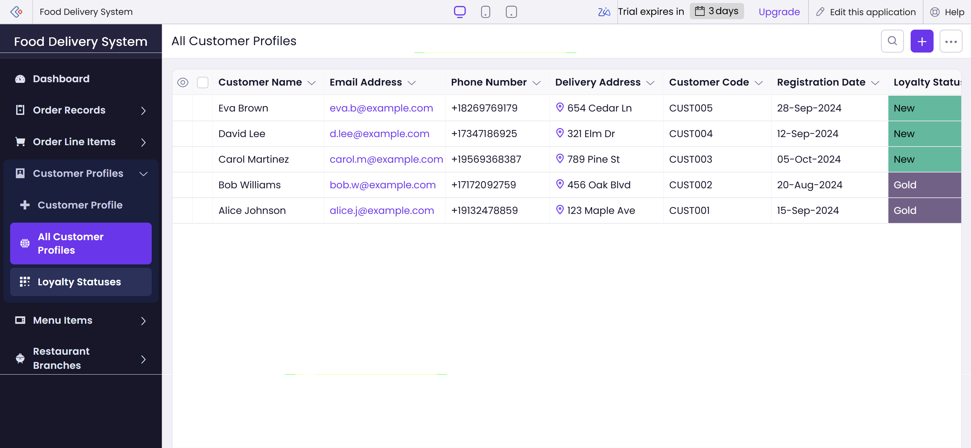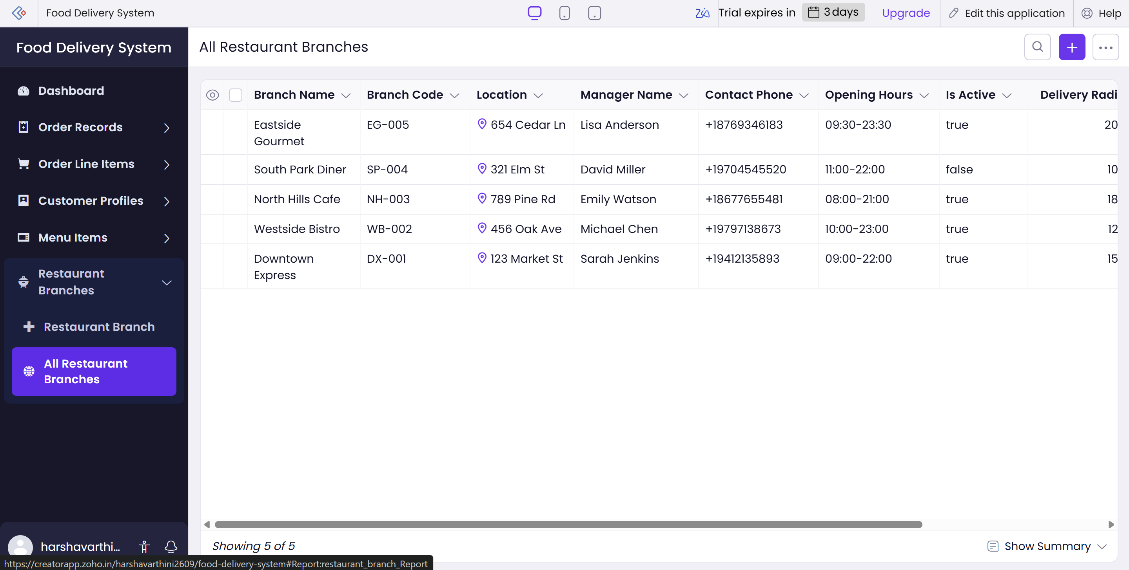

Result:
The experiment was successfully completed by studying application building with Zia Assistant in Zoho Creator. A Student Registration System was selected as the practical application, demonstrating how natural-language requirements can be used to assist in creating forms, reports, and related application components with reduced manual coding.

